We realize the loss of a loved one can be a difficult and overwhelming time for your family and loved ones. This toolkit has been developed to help answer some questions and to prepare you and your family for what happens next.
This guide is meant to be a first step and is by no means comprehensive. We encourage you to seek legal, tax, or financial planning or investment advice as you see fit.
123.456.7890 www.website.com
Survivor Checklist – 2
Funeral Planning Checklist – 3
Final Arrangements – 4
Account Settlement – 5
Timeline – 8
Planning My Funeral – 9
Financial Accounts – 12

Survivor Checklist

The sidebar is a place we can use to describe the purpose of the information on the page, give a summary, or provide additional details.
Who to Notify Before Death
- Family that you are pre-planning your funeral/making arrangements for when you pass
- Funeral home
- Financial institutions who your POD will be

Who to Notify After Death

- Family
- Close friends
- Doctors
- Lawyers
- Social Security
- Landlord
- Nursing home
- Assisted living facility
- Employer
- Insurance
- Credit Bureau
- Financial Institutions
- Post Office

Things to Cancel/Monitor

- Driver’s license
- Membership to organizations
- Election board
- Cable
- Cell phone
- TV
- Internet
- Utilities (though do not cancel right away)
- Automatic payments
- Email accounts
- Loans
- Insurance
- Property tax

Other
- Pets need taken care of
- Secure property/valuables of deceased
- Death certificates ordered (12-15 is a good number to start with)
CU Name
123.456.7890
www.cuwebsite.org

Funeral Planning Checklist

The sidebar is a place we can use to describe the purpose of the information on the page, give a summary, or provide additional details.

General Preparations
  - Assemble personal information for obituary
  - Choose a charity to direct donations to
  - Decide if jewelry is to remain or be returned
  - Choose a funeral home

Funeral Home Services
  - Choose burial or cremations
  - Select a casket or cremation container
  - Select a burial vault or cremation urn
  - Choose the location/type of service
  - Choose family viewing or visitation
  - Choose a floral arrangement
  - Select a photograph to be displayed
  - Decide which religious or fraternal items are to be displayed
  - Decide what the deceased will wear
  - Select music, hymns, and solos
  - Select scripture or literature to be read
  - Select a memorial register
  - Select memorial folders and acknowledgement cards

Funeral Home Services: Transportation

  - Funeral coach
  - Clergy car
  - Family limousine
  - Pallbearer limousine
  - Flower car

Participants
  - Choose clergy or officiator
  - Choose organist or other musical participants
  - Select pallbearers
  - Select family member or friend to perform the eulogy
  - Select family member or friend to read scripture or literature

Cemetery Selections
  - Choose a cemetery
  - Select a burial or cremation plot
  - Decide whether above or below ground
CU Name
123.456.7890
www.cuwebsite.org
  - Select a memorial or grave marker and inscription

Final Arrangements

The sidebar is a place we can use to describe the purpose of the information on the page, give a summary, or provide additional details.

- Ambulance transfer from place of death
- Apply for death certificates
- Apply for burial permit
- Set a time and date for the service
- Request preparation and embalming
- Compose and submit obituary
- Arrange location and food for the reception
CU Name
123.456.7890
www.cuwebsite.org

Account Settlement

The sidebar is a place we can use to describe the purpose of the information on the page, give a summary, or provide additional details.

[Sidebars are great for calling out important points from your text or adding additional info for quick reference, such as a schedule.
They are typically placed on the left, right, top or bottom of the page. But you can easily drag them to any position you prefer.
When you’re ready to add your content, just click here and start typing.]

[Sidebars are great for calling out important points from your text or adding additional info for quick reference, such as a schedule.
They are typically placed on the left, right, top or bottom of the page. But you can easily drag them to any position you prefer.
When you’re ready to add your content, just click here and start typing.]

Legal Considerations and Documents
Death Certificate – get duplicate copies of the death certificate. It is possible the funeral director may help you handle this, or you can order them from the vital statistics office of Indiana. Each certified copy will cost in the range of $10 to $20.
Cancel Driver’s License – removing your loved one’s driver’s license will remove the file from the department of motor vehicles and will help prevent identity theft. Contact the Indiana Bureau of Motor Vehicles for specific information on terminating this record.
Account Settlement
Accounts are reconciled for your loved one’s account based upon ownership type. In any situation where the survivor is not a beneficiary or a joint owner on the account, the credit union will maintain the account as reportable to the IRS until it is reconciled. Settlement is recommended as quickly possible in order to avoid complications resulting from continued IRS reporting under the deceased’s SSN.
Accounts with a Designated Beneficiary
Accounts with one or more designated beneficiaries are easily reconciled. As a beneficiary you will receive the percentage of assets granted to you by your loved one. A signature along with a copy of a photo ID is all that is needed to receive the portion to be dispersed to each beneficiary.
Jointly Owned Account Spouse/Non Spouse
Any account in which one of the joint owners passes away will be owned by the survivor(s). A copy of the deceased’s death certificate along with a signature to remove the loved one from the account will be needed. In some circumstances, the account will need to be terminated and the survivor(s) will need to open a new account.
Accounts with a Single Owner
In order to settle a single owner’s account, a photocopy of the deceased’s death certificate will be required. All federal benefit payments (Social Security and other Retirement deposits) received in your loved one’s name after the date of death will be returned. Any checks written prior to the deceased’s passing will continue to be paid for 10 days from the date of death. Previously authorized
CU Name
123.456.7890
www.cuwebsite.org
[Continued on next page]

electronic payments, including scheduled online banking payments, may be paid for up to 30 days.

The sidebar is a place we can use to describe the purpose of the information on the page, give a summary, or provide additional details.

If an estate is being set up, we will also need a copy of the “Letters Testamentary” or “Notice of Administration of the Estate”. If an estate is not required and your loved one was an Indiana resident, we may be able to provide a Small Estate Affidavit after 45 days have passed.
Payments to any loans on this account may continue to be made while the estate is being settled. Payments can be made by mailing the payment to the address listed above and indicating the deceased’s name and loan type in the memo line. Payments can also be made at any {CU} location.
Payable on Death Accounts
Any funds in accounts marked Payable on Death will be provided to the beneficiary(ies) upon the passing of the loved one with a copy of the owner(s) Death Certificate.
Trust Accounts
Any trust account that was designated to your loved one can be settled with a copy of the death certificate and the trust pages listing the successor trustee are required.
Safe Deposit Box Ownership
Any safe deposit boxes owned solely by the decedent may be accessed and closed by a personal representative with “Letters of Administration”. Any box belonging to one or more other owners will require a Lease Amendment to remove the deceased.
IRAs, HSAs, or ESAs with the Credit Union
A death claim is filed for your loved one’s IRA, HSA, or ESA once the credit union receives the death certificate. These items will not be closed until a Dispersal Authorization is received from the provider of these items.
Establishing an Estate Account
Estate accounts are created to provide a safe, short-term vehicle for funds while an estate is settled, and will have its own Taxpayer ID Number provided by the IRS. This Taxpayer ID Number along with a copy of the Death Certificate are required in order to open an estate account.
Need advice about what to do with the disposition of accounts and assets? Financial representatives from the credit union can offer professional re-investment guidance on accounts held at the credit union, and they can provide advice about stocks, bonds, mutual funds, and life and long-term care insurance.
CU Name
123.456.7890
www.cuwebsite.org

Insurance

Social Security Office
800-772-1213
Medicare
800-663-4227

Social Security Office – typically the funeral director will notify the Social Security Office of your loved one’s death. If not, call your local office. If your loved one received Social Security benefits, they must promptly stop to remove the possibility of overpayments, which can be timely to repay.
Medicare – if your loved one received Medicare, the Social Security office will inform the program of the death. If, however, any additional Medicare coverage was provided to your loved one, contact them on the number listed on the back of the insurance card in order to cancel coverage.
Heath Insurance – Notify the insurance company or your loved one’s employer in order to discontinue health insurance. When doing so, ensure you are not canceling insurance of any survivors also included in the plan.
Life Insurance – if your loved one had life insurance, notify the companies of their passing. Appropriate claim forms will need to filed and will be provided by the company. The policy number and death certificate will be required. Be sure to check that your loved one was not a beneficiary on any other life insurance policies and have them removed if so.
Terminate other Insurance Policies – this could include homeowner’s insurance, automobile insurance, etc. A copy of the death certificate will be required to discontinue coverage.

Timeline
CU Name
123.456.7890
www.cuwebsite.org

The sidebar is a place we can use to describe the purpose of the information on the page, give a summary, or provide additional details.

What to do right away

- Get a legal pronouncement of death (Doctor, Hospice nurse, or 911)
- Arrange for transportation of loved one
- Notify their doctor or Coroner
- Notify immediate family (ask some to contact others)
- Handle care of dependents and/or pets
- Call their employer
What to do in the first few days
- Arrange for funeral and burial or cremation (look for preplanned (prepaid burial plan)
- If military or belonged to fraternal or religious group contact the organization (they may have burial benefits or conduct funeral services
- Keep an eye on phone calls, voicemails, and collect mail (throw out food and water plants)
What to do within the first few weeks
- Obtain death certificate (most research shows to request around 10 copies as most places need the official copy)
- Take the will to the appropriate county or city office to have it accepted for probate
- If there is an estate the executor should open a bank account (with a Credit Union)
- Contact the trust or estate attorney to learn how to transfer the assets and assist with probate
- Periodically check the house for condition if vacant
- Contact an account to see if an estate-tax return or final income-tax return should be filed
- Contact their investment advisor or pension plan provider
- Contact their Credit Union or bank
- Contact life insurance company to get claim forms
- Contact Social Security (800-722-1213)
- Contact Veterans Affairs if applicable (800-827-1000)
- Contact the utility companies to change or stop services and the post office to stop or forward mail
What to have done within 90 days
- Ensure that all financial accounts have been settled
- Settle all loans with financial institutions if needed
CU Name
123.456.7890
www.cuwebsite.org
- Disperse or settle and disperse all real estate or real estate proceeds

Planning My Funeral

The sidebar is a place we can use to describe the purpose of the information on the page, give a summary, or provide additional details.

Decide on the type of service you want to have
- I would like to have a funeral service, followed by burial or cremation
- I would like to have a funeral service, followed by a graveside service or a service at the crematory, followed by burial or cremation
- I would like to have only a graveside service or a service at the crematory, followed by burial or cremation
- I would like to have a memorial service after the burial or cremation
- I would like to have a funeral service in my own home
Decide if you want any other funeral events
- I would like to have a viewing before my funeral
- I would like to have a wake before my funeral
- I would like to have a visitation before my funeral
- I would like to have a reception or gathering after my funeral or memorial service
- I would like to observe my religion’s mourning events
Identify personal touches you’d like at the service
- I would like my funeral or memorial service to be held at the following location: ______________________________________.
- If this location is not available, my second choice is ______________________________________.
- The person I would like to officiate my funeral or memorial service is ______________________________________.
- If this person is not available, my second choice is ______________________________________.

I would like the following people to serve as pallbearers:
1. _____________________________
2. _____________________________
3. _____________________________
4. _____________________________
5. _____________________________
6. _____________________________
CU Name
123.456.7890
www.cuwebsite.org

I would like the following people to deliver eulogies:

The sidebar is a place we can use to describe the purpose of the information on the page, give a summary, or provide additional details.

1. _____________________________
2. _____________________________
3. _____________________________
I would like the following people to deliver prayers, poems, or other readings:
1. _____________________________
2. _____________________________
3. _____________________________
The readings I would like them to deliver are:
1. __________________________________________________
2. __________________________________________________
3. __________________________________________________
I would like the following songs, hymns, or pieces of music to be played:
1. _____________________________
2. _____________________________
3. _____________________________
I would like people to honor my memory by making a donation to one of the charity organizations that has meant a lot to me:
1. _____________________________
2. _____________________________
3. _____________________________
I want to be sure that the following groups, organizations, and clubs will be notified of and invited to my funeral or memorial service (such as veterans’ groups, alumni associations, sports or hobby clubs, etc.):
Name of Group/Primary Contact/Contact Info
1. _______________________________________________
CU Name
123.456.7890
www.cuwebsite.org
2. _______________________________________________
3. _______________________________________________

I want to be sure that the following people, whom my family may not know, will be notified of and invited to my funeral or memorial service:

The sidebar is a place we can use to describe the purpose of the information on the page, give a summary, or provide additional details.

Name/Contact Info
1. ________________________________________________
2. ________________________________________________
3. ________________________________________________
4. ________________________________________________
5. ________________________________________________
6. ________________________________________________
7. ________________________________________________
8. ________________________________________________
9. ________________________________________________
10. _______________________________________________
11. _______________________________________________
12. _______________________________________________
13. _______________________________________________
14. _______________________________________________
15. _______________________________________________
16. _______________________________________________
17. _______________________________________________
18. _______________________________________________
19. _______________________________________________
20. _______________________________________________

Financial Accounts & Assets
CU Name
123.456.7890
www.cuwebsite.org
CU Name
123.456.7890
www.cuwebsite.org

The sidebar is a place we can use to describe the purpose of the information on the page, give a summary, or provide additional details.

Important Contacts
- Accountant name/info:

- Financial advisor name/info:

- Lawyer name/info:

- Other name/info:

Bank Accounts - have a recent account statement for each, location of related items (example: checkbooks, passbooks), and login information for online management.

  - Checking bank: last 4 digits:
  - Savings bank: last 4 digits:
  - ATM/debit bank: last 4 digits:
  - Other:
Investments / Pensions / Benefits - have a recent statement for each account, as well as login information for online management.

- Stocks/Bonds
- Mutual funds
- Military benefits
- 401(k)
- 403(b)
- IRA
- Roth IRA
- Pension (SEP / SARSEP)
- 529/college savings

- Other (trust fund, business interests/stock options):

Credit Cards - have a recent statement for each card, as well as login information for online management. You can list any rewards you receive for using the card next to “benefits.”

- Credit Card #1
Last 4 digits: Exp. Date: Benefits:

CU Name
123.456.7890
www.cuwebsite.org
- Credit Card #2
Last 4 digits: Exp. Date: Benefits:

- Credit Card #3

The sidebar is a place we can use to describe the purpose of the information on the page, give a summary, or provide additional details.

Last 4 digits: Exp. Date: Benefits:

- Credit Card #4
Last 4 digits: Exp. Date: Benefits:

- Other:

Write the name of the store-based credit card (example: Target, Exxon, Wal-Mart, etc.); have a recent statement for each and the login information for online management.
- Store:
Last 4 digits: Exp. Date: Benefits:

- Store:
Last 4 digits: Exp. Date: Benefits:

- Store:
Last 4 digits: Exp. Date: Benefits:

- Store:
Last 4 digits: Exp. Date: Benefits:

- Other:

Tax returns - these are the ideal financial blueprints for people in your life to understand your estate.
- Location of recent tax returns:

- Tax prep (circle one): accountant | software/online service

- Name of accountant or service:

- Contact or login info:
CU Name
123.456.7890
www.cuwebsite.org

- Additional info:

The sidebar is a place we can use to describe the purpose of the information on the page, give a summary, or provide additional details.

Property: Owned

The sidebar is a place we can use to describe the purpose of the information on the page, give a summary, or provide additional details.

- Address:

- Location of deed:

- Location of mortgage paperwork:

- Mortgage company name/contact info:

- Account number (if applicable):

- Additional info:

Property: Rented
- Address:

- Location of lease:

- Landlord contact info:

- Monthly rent: Security deposit:

- Lease end date:

- Additional info:

Vehicles

- Vehicle type:

- Ownership status (circle one): owned (financed) | leased | owned & paid off location of title/lease:

- Finance company (if applicable): additional info:

CU Name
123.456.7890
www.cuwebsite.org
- Vehicle type:

The sidebar is a place we can use to describe the purpose of the information on the page, give a summary, or provide additional details.

- Ownership status (circle one): owned (financed) | leased | owned & paid off location of title/lease:

- Finance company (if applicable): additional info:

Loans - Keep track of the following info and once the loan is paid off feel free to mark it “paid” and celebrate.
- Type of loan (circle one): line of credit | personal loan | student loan | other name of financial institution:

- Account number:

- Location of related documents:

- Additional details & instructions:

- Type of loan (circle one): line of credit | personal loan | student loan | other name of financial institution:

- Account number:

- Location of related documents:

- Additional details & instructions:

Safe deposit box - Ensure someone you trust knows how to access your safe deposit box.
- Name of bank/branch location:

- Account number: box number:

- Key location:
CU Name
123.456.7890
www.cuwebsite.org

- Authorized users contact info:
CU Name
123.456.7890
www.cuwebsite.org
- Additional details & instructions:

Other Valuables & Assets

The sidebar is a place we can use to describe the purpose of the information on the page, give a summary, or provide additional details.

- Keep track of any valuables, cash, or other assets you don’t want disappearing after you’re gone

- Asset & location:

- Asset & location:

- Asset & location:
CU Name
123.456.7890
www.cuwebsite.org

- Asset & location:

Use this page to write any other essential information

The sidebar is a place we can use to describe the purpose of the information on the page, give a summary, or provide additional details.

CU Name
123.456.7890
www.cuwebsite.org

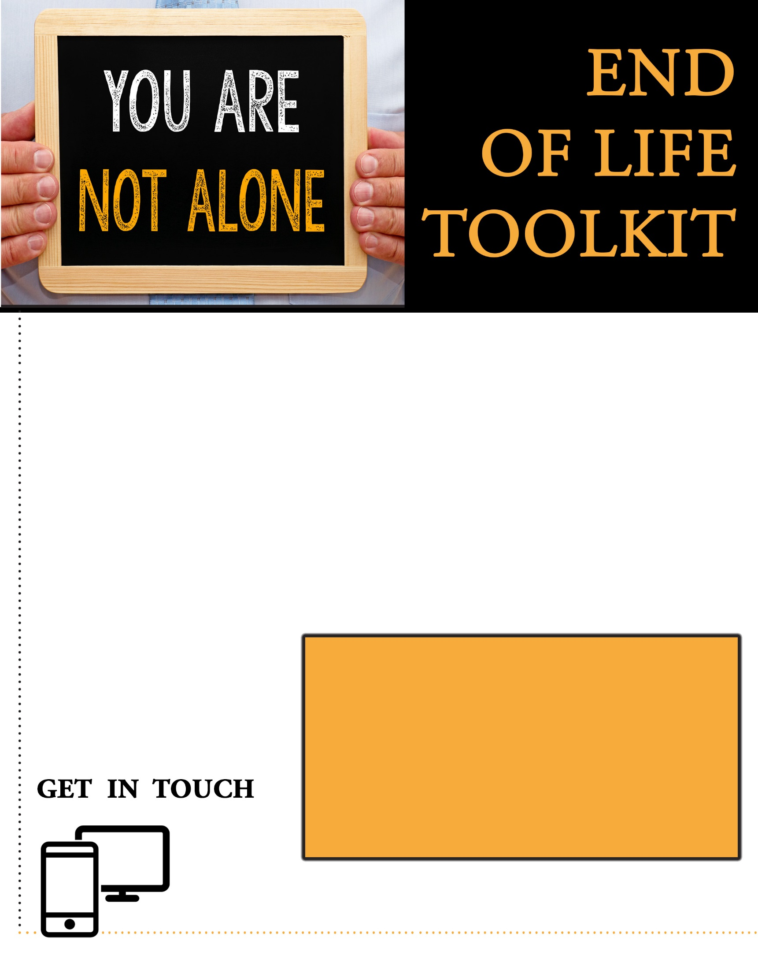
123.456.7890 www.website.com
WHEN TO SEEK LEGAL ADVICE?
- When establishing or changing a Living Will
- When establishing an Estate or Trust
- When establishing a Durable POA or POA

KNOWING THE DIFFERENCE IS IMPORTANT
Pre-planning for the next chapter can be a difficult step to take, especially if you feel like you are taking this step alone. We have designed this toolkit to help with preparation and guidance to ensure that you have somewhere to turn when getting your affairs in order.
With all of the DIY legal advice that is in the market today, we want to ensure that our members are seeking legal advice at the right time. Pre-planning is the best time to seek council for most documentation that will be completed prior to your passing. Planning is key for this life event.

